JSPM’s
RAJARSHI SHAHU COLLEGE OF ENGINEERING
TATHAWADE, PUNE-33
(An Empowered Autonomous Institute Affiliated to Savitribai Phule Pune University, Pune)

Mini Project
on
“Breast Cancer Diagnosis using Machine Learning”

-Submitted by-

Lazina Shaikh
PRN: RBT24CS136 Roll No: 64

Class and Division: TY Div B
Course: Machine Learning
Academic Year 2026-27
(Semester-I)

Project guide/Faculty sign
Prof.Rushali Deshmukh
Faculty,Machine Learning
Title
Breast Cancer Diagnosis (Benign vs Malignant) using Machine Learning Classification Algorithms
- Abstract
Breast cancer is one of the most common cancers among women, and early, accurate diagnosis greatly improves the chances of successful treatment. This mini project applies supervised machine learning to classify breast tumours as benign or malignant using the Wisconsin Diagnostic Breast Cancer (WDBC) dataset, which contains 569 samples described by 30 numerical features computed from digitised images of fine needle aspirates.
After data cleaning and exploratory data analysis, the data was split 80:20 with stratification, standardised, and reduced from 30 to 8 features using a correlation filter followed by ANOVA F-test selection. Seven classifiers (Logistic Regression, K-Nearest Neighbours, Decision Tree, Support Vector Machine, Random Forest, AdaBoost and Gradient Boosting) were trained and compared using accuracy, precision, recall, F1-score, AUC, confusion matrices and ROC curves. The models were then checked with 5-fold cross-validation and tuned with GridSearchCV using recall as the scoring metric.
The tuned Logistic Regression model gave the best result on the test set: 96.49% accuracy, 97.50% precision, 92.86% recall, 95.12% F1-score and an AUC of 0.9947. Out of 42 malignant cases it detected 39 and raised only one false alarm.
- Introduction
Breast cancer occurs when cells in the breast grow abnormally and form a tumour. A tumour may be benign (non-cancerous and not spreading) or malignant (cancerous and able to spread). A common first step in diagnosis is a fine needle aspiration (FNA) test, in which a small sample of cells is taken from the breast mass, examined under a microscope and photographed. From the digitised image, the size and shape of each cell nucleus can be measured.
Machine learning is well suited to this task. A supervised learning algorithm can learn from past cases, in which the measurements and the confirmed diagnosis are both known, and then predict the diagnosis of a new case from its measurements alone. Such a system does not replace the doctor, but it can act as a fast and consistent second opinion.
In this project, seven classification algorithms of increasing complexity are applied to the Wisconsin Diagnostic Breast Cancer dataset. Because missing a cancer case is far more dangerous than a false alarm, the project gives special importance to recall (sensitivity) in addition to overall accuracy.
- Problem Statement
To design, train and compare supervised machine learning classification models that predict whether a breast tumour is benign (0) or malignant (1) from the 30 numerical cell-nucleus measurements in the WDBC dataset, and to select the model that detects malignant tumours most reliably (highest recall) while keeping overall accuracy, precision and F1-score high.
- Objectives
- To load, clean and explore the dataset (shape, missing values, duplicates, class balance, distributions and correlations).
- To pre-process the data: encode the target, split it into stratified training and test sets, standardise the features, visualise it with PCA and select the most useful features.
- To train seven classifiers: Logistic Regression, KNN, Decision Tree, SVM, Random Forest, AdaBoost and Gradient Boosting.
- To evaluate every model using accuracy, precision, recall, F1-score, AUC, confusion matrices and ROC curves.
- To check the stability of the models with stratified 5-fold cross-validation.
- To tune hyperparameters with GridSearchCV (scoring on recall) and compare base and tuned models.
- To find the most important features using Random Forest and Gradient Boosting.
- To save the best model, scaler and feature lists with joblib and demonstrate a prediction on a sample patient.
- Data set and Libraries required
6.1 Data set
The Wisconsin Diagnostic Breast Cancer (WDBC) dataset is used (file name: data.csv). Each row describes one breast mass. Ten real-valued characteristics are computed for each cell nucleus, and for each one the mean, the standard error (se) and the worst (largest) value are recorded, giving 30 features per sample.
Table 1: Summary of the data set
Property | Details
Number of samples | 569
Class distribution | 357 Benign (62.7%) and 212 Malignant (37.3%)
Raw file shape | 569 rows x 33 columns (id, diagnosis, 30 features and one empty unnamed column)
Shape after cleaning | 569 rows x 31 columns (30 features + diagnosis)
Features (30) | radius, texture, perimeter, area, smoothness, compactness, concavity, concave points, symmetry and fractal dimension, each as _mean, _se and _worst
Target | diagnosis: M (Malignant) encoded as 1, B (Benign) encoded as 0
Missing values / duplicates | 0 / 0
Train / test split | 455 / 114 samples (80:20, stratified). Test set: 72 benign and 42 malignant

6.2 Libraries required
The project is written in Python 3 and run in a Jupyter / Google Colab notebook.
Table 2: Libraries and their purpose
Library | Purpose
NumPy, Pandas | Numerical arrays, loading data.csv, cleaning and tabular results
Matplotlib, Seaborn | All graphs: histograms, box plots, heatmaps, confusion matrices, ROC curves
scikit-learn: model_selection | train_test_split, StratifiedKFold, cross_val_score, GridSearchCV
scikit-learn: preprocessing, decomposition, feature_selection | StandardScaler, PCA, SelectKBest with f_classif
scikit-learn: classifiers | LogisticRegression, KNeighborsClassifier, DecisionTreeClassifier, SVC, RandomForestClassifier, AdaBoostClassifier, GradientBoostingClassifier
scikit-learn: metrics | accuracy, precision, recall, F1, confusion matrix, ROC curve, AUC, classification report
joblib | Saving and loading the trained model, scaler and feature lists
os, math, warnings | Folder creation for graphs, layout calculation and warning control

- Approach/ Methodology
The project follows a standard supervised machine learning pipeline:
Step 1. Data loading and cleaning: read data.csv, tidy column names, drop the id and empty unnamed columns, encode diagnosis (M = 1, B = 0), and check for missing values and duplicates.
Step 2. Exploratory data analysis (EDA): class distribution, histograms, box plots, correlation heatmap, correlation of each feature with the target, and a pair plot of the top features.
Step 3. Train/test split and scaling: 80:20 stratified split (random_state = 42); StandardScaler fitted on the training data only and then applied to the test data to avoid data leakage.
Step 4. PCA visualisation: the scaled data is projected to two principal components to see how well the two classes separate.
Step 5. Feature selection (on training data only): remove one of every pair of features with correlation above 0.90 (30 to 20 features), then keep the best 8 using SelectKBest with the ANOVA F-score.
Step 6. Model training: seven classifiers at basic, intermediate and advanced level are trained on the scaled, selected features.
Step 7. Evaluation: accuracy, precision, recall, F1-score, AUC, confusion matrix and ROC curve for every model on the test set.
Step 8. Cross-validation: stratified 5-fold cross-validation using recall as the score.
Step 9. Hyperparameter tuning: GridSearchCV (5-fold, scoring = recall) for every model, followed by re-evaluation of the tuned models.
Step 10. Model comparison and selection: base and tuned results are compared; the best model is the one with the highest recall (ties broken by F1-score). It is saved with joblib and tested on a sample patient.
7.1 Algorithms used
Table 3: Classification algorithms and base settings (random_state = 42 wherever applicable)
Level | Algorithm | Base configuration | Idea
Basic | Logistic Regression | max_iter = 1000 | Linear model that gives the probability of the malignant class using the sigmoid function
Basic | K-Nearest Neighbours | n_neighbors = 5 | Classifies a sample by the majority class of its 5 closest training samples
Basic | Decision Tree | default | Series of if-else splits on feature values
Intermediate | SVM | probability = True (RBF kernel) | Finds the boundary with the maximum margin between the classes
Intermediate | Random Forest | n_estimators = 200 | Many decision trees trained on random subsets; majority vote
Advanced | AdaBoost | n_estimators = 100, learning_rate = 0.5 | Boosting: each weak learner focuses on the previous errors
Advanced | Gradient Boosting | n_estimators = 100, learning_rate = 0.1, max_depth = 3 | Boosting: each tree corrects the residual error of the ensemble

7.2 Evaluation metrics
Malignant is the positive class. TP = malignant correctly detected, TN = benign correctly identified, FP = benign wrongly called malignant (false alarm), FN = malignant wrongly called benign (missed cancer).
Table 4: Evaluation metrics
Metric | Formula | Meaning
Accuracy | (TP + TN) / total | Share of all predictions that are correct
Precision | TP / (TP + FP) | Of the tumours predicted malignant, how many really are
Recall | TP / (TP + FN) | Of the real malignant tumours, how many were found (most important here)
F1-score | 2 x P x R / (P + R) | Balance between precision and recall
AUC | Area under ROC curve | Ability to separate the classes at all thresholds (1.0 is perfect)

- Implementation
The complete implementation is in a single Python notebook (ml_mini_project_.ipynb). The main parts are shown below with the important code and the graphs they produced.
8.1 Data loading and cleaning
df = pd.read_csv("data.csv")
df.columns = df.columns.str.strip().str.lower()
drop_cols = [c for c in df.columns if c == "id" or c.startswith("unnamed")]
df = df.drop(columns=drop_cols)

df["diagnosis"] = (df["diagnosis"].astype(str).str.strip().str.upper().str[0]
.map({"M": 1, "B": 0}))
df = df.dropna(axis=1, how="all").dropna(subset=["diagnosis"])
df["diagnosis"] = df["diagnosis"].astype(int)

print("Missing values:", df.isnull().sum().sum()) # 0
print("Duplicate rows:", df.duplicated().sum()) # 0
The raw data had the shape (569, 33). After removing the id and empty unnamed columns and encoding the target, the shape became (569, 31) with no missing values and no duplicate rows.
8.2 Exploratory data analysis
The class counts are 357 benign and 212 malignant, so the data is moderately imbalanced. This is one reason why a stratified split is used and why recall is monitored closely.
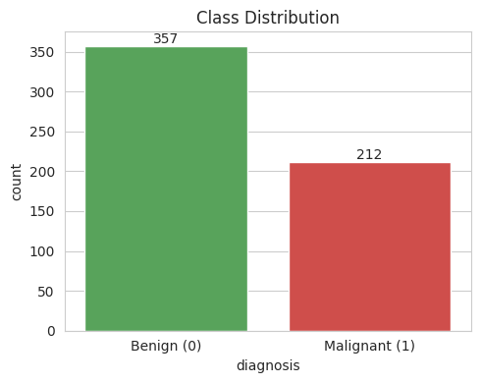
Figure 1: Class distribution (0 = Benign, 1 = Malignant)
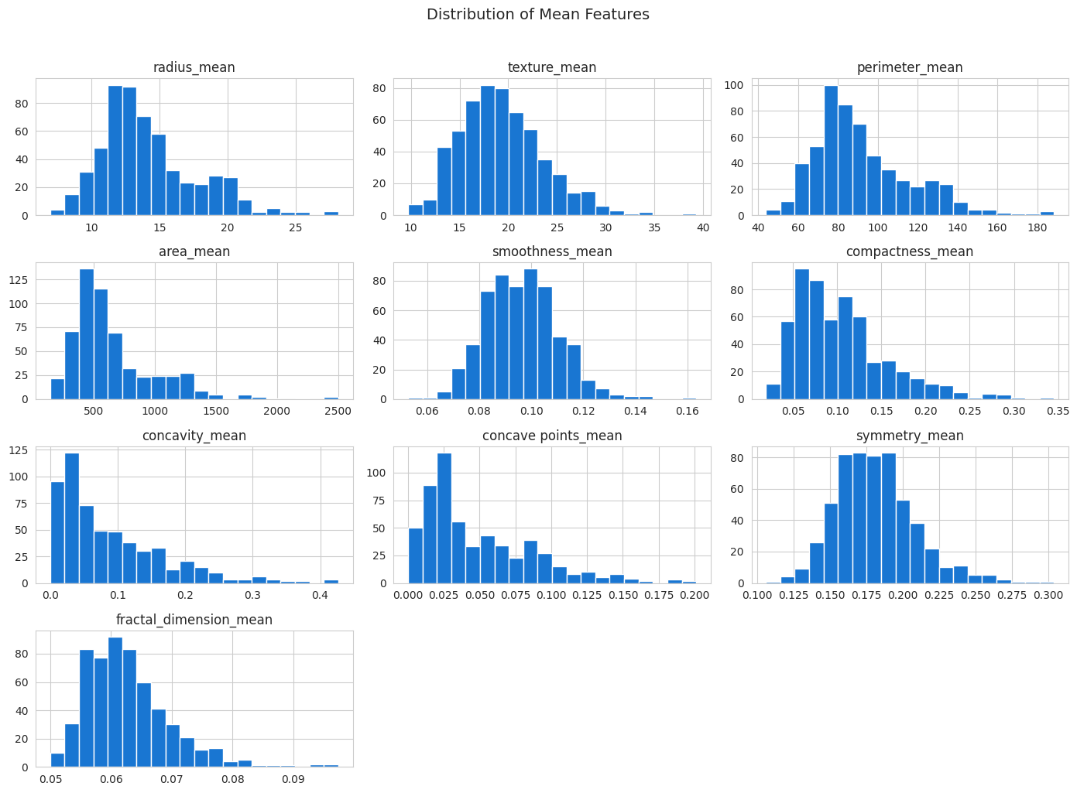
Figure 2: Histograms of the first ten mean features
Box plots show that malignant tumours (M) generally have higher medians for radius, perimeter, area, concavity and concave points than benign tumours (B), so these features separate the two classes well.
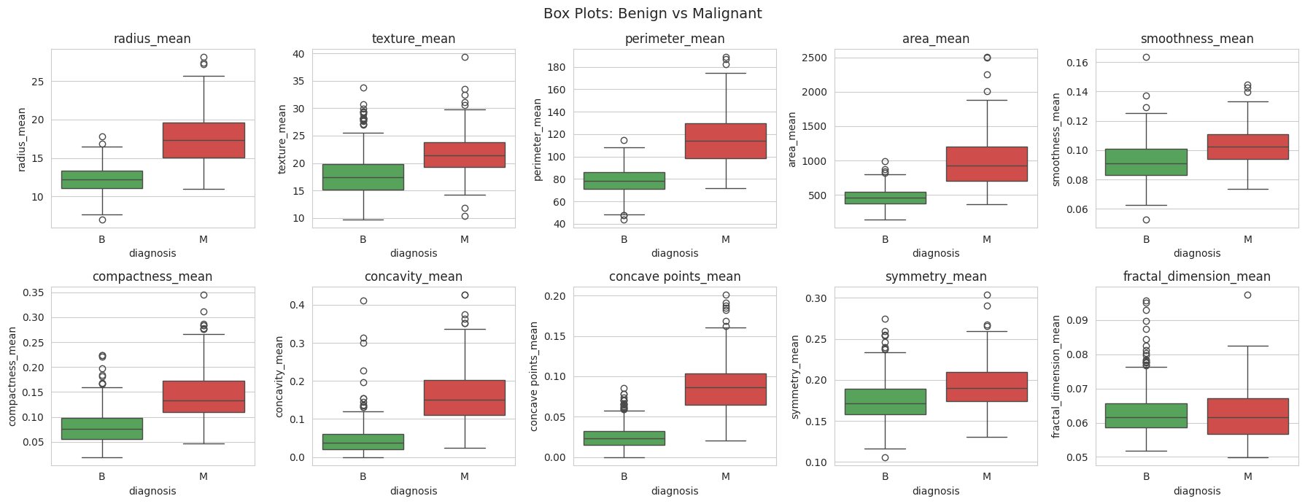
Figure 3: Box plots of the mean features for benign and malignant tumours
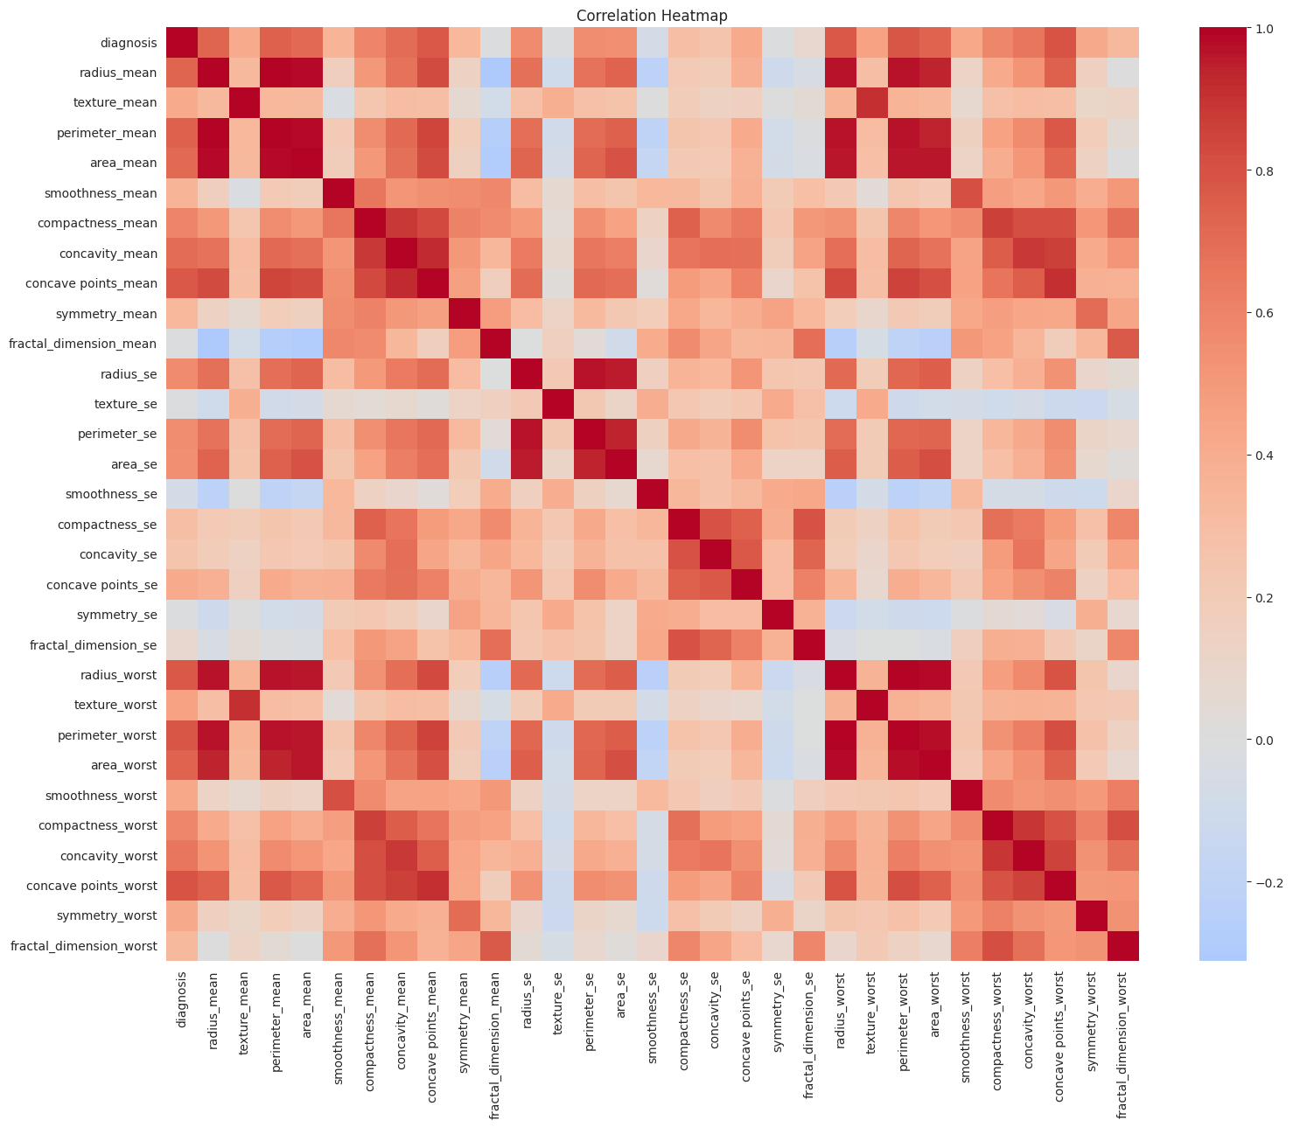
Figure 4: Correlation heatmap of all features
The heatmap shows strong correlation between size-related features (radius, perimeter and area), which means many features carry the same information. This motivates the feature selection step. The features most correlated with the diagnosis are shown below.
Table 5: Top 5 features correlated with the diagnosis
Feature | Correlation with diagnosis
concave points_worst | 0.7936
perimeter_worst | 0.7829
concave points_mean | 0.7766
radius_worst | 0.7765
perimeter_mean | 0.7426

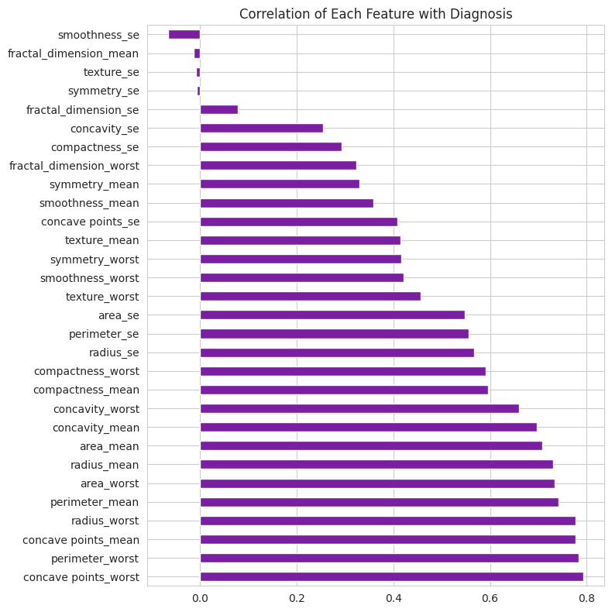
Figure 5: Correlation of each feature with the diagnosis
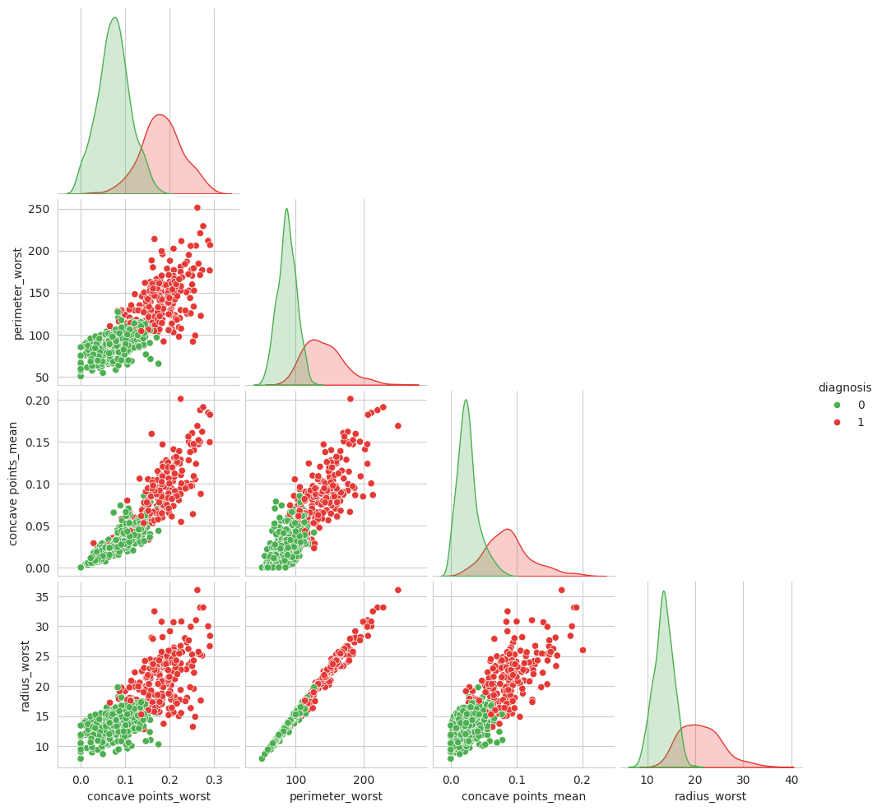
Figure 6: Pair plot of the four features most correlated with the diagnosis
8.3 Train/test split, scaling and PCA
X = df.drop("diagnosis", axis=1)
y = df["diagnosis"]
X_train, X_test, y_train, y_test = train_test_split(
X, y, test_size=0.2, random_state=42, stratify=y)

scaler = StandardScaler()
X_train_s = scaler.fit_transform(X_train)
X_test_s = scaler.transform(X_test)

pca = PCA(n_components=2)
X_pca = pca.fit_transform(scaler.transform(X))
The training set has 455 samples and the test set has 114 samples. The scaler is fitted only on the training data. The PCA plot shows that the benign and malignant samples form two largely separate groups, so the classes can be separated well by the features.
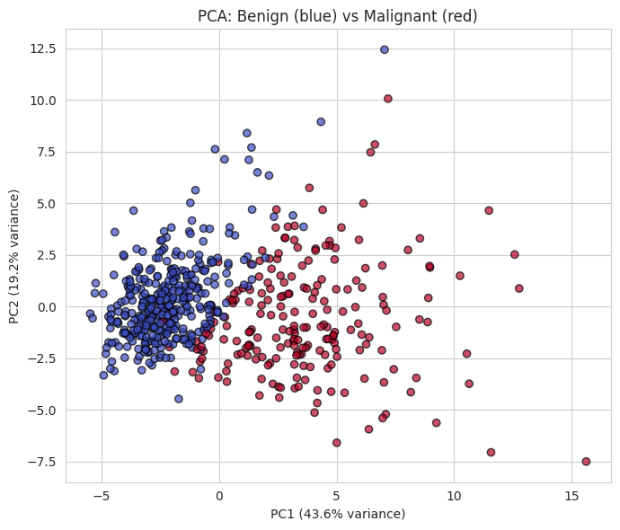
Figure 7: PCA projection: benign (blue) vs malignant (red)
8.4 Feature selection
CORR_THRESHOLD = 0.90
TOP_K = 8
corr = X_train.corr().abs()
upper = corr.where(np.triu(np.ones(corr.shape), k=1).astype(bool))
to_drop = [c for c in upper.columns if (upper[c] > CORR_THRESHOLD).any()]
kept = [c for c in X_train.columns if c not in to_drop]

skb = SelectKBest(score_func=f_classif, k=TOP_K).fit(X_train[kept], y_train)
selected_features = [str(f) for f in np.array(kept)[skb.get_support()]]
The correlation filter dropped 10 highly correlated features (perimeter_mean, area_mean, concave points_mean, perimeter_se, area_se, radius_worst, texture_worst, perimeter_worst, area_worst and concave points_worst), leaving 20. SelectKBest then kept the 8 features with the highest F-scores:
radius_mean, compactness_mean, concavity_mean, radius_se, smoothness_worst, compactness_worst, concavity_worst, symmetry_worst
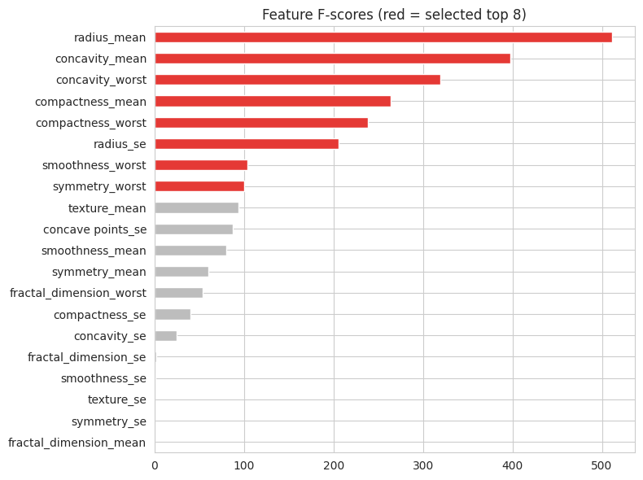
Figure 8: Feature F-scores (red = selected top 8)
8.5 Model training and evaluation
models = {
"Logistic Regression": LogisticRegression(max_iter=1000, random_state=42),
"KNN": KNeighborsClassifier(n_neighbors=5),
"Decision Tree": DecisionTreeClassifier(random_state=42),
"SVM": SVC(probability=True, random_state=42),
"Random Forest": RandomForestClassifier(n_estimators=200, random_state=42),
"AdaBoost": AdaBoostClassifier(n_estimators=100, learning_rate=0.5,
random_state=42),
"Gradient Boosting": GradientBoostingClassifier(n_estimators=100,
learning_rate=0.1, max_depth=3, random_state=42),
}
A reusable function, evaluate(), trains each model on X_train_s, predicts on X_test_s and calculates accuracy, precision, recall, F1-score and AUC. It also plots the confusion matrix of every model and one combined ROC curve, and prints the classification report. The same function is used again for the tuned models.
def evaluate(models_dict, title_suffix=""):
for name, model in models_dict.items():
model.fit(X_train_s, y_train)
pred = model.predict(X_test_s)
prob = model.predict_proba(X_test_s)[:, 1]
fpr, tpr, _ = roc_curve(y_test, prob)
rows[name] = {"Accuracy": accuracy_score(y_test, pred),
"Precision": precision_score(y_test, pred),
"Recall": recall_score(y_test, pred),
"F1-Score": f1_score(y_test, pred),
"AUC": auc(fpr, tpr)}
return pd.DataFrame(rows).T
8.6 Cross-validation
cv = StratifiedKFold(n_splits=5, shuffle=True, random_state=42)
for name, model in models.items():
scores = cross_val_score(model, X_train_s, y_train, cv=cv, scoring="recall")
8.7 Hyperparameter tuning with GridSearchCV
For each model a grid of parameters was searched with 5-fold cross-validation, using recall as the scoring metric, and the best estimator was kept.
gs = GridSearchCV(model, grid, cv=5, scoring="recall", n_jobs=-1)
gs.fit(X_train_s, y_train)
tuned_models[name] = gs.best_estimator_
Table 6: Parameter grids searched
Model | Parameters and values searched
Logistic Regression | C: 0.01, 0.1, 1, 10, 100; penalty: l2
KNN | n_neighbors: 3, 5, 7, 9, 11; weights: uniform, distance
Decision Tree | max_depth: 3, 5, 7, None; min_samples_split: 2, 5, 10
SVM | C: 0.1, 1, 10, 100; kernel: linear, rbf; gamma: scale, auto
Random Forest | n_estimators: 100, 200, 300; max_depth: None, 5, 10; min_samples_split: 2, 5
AdaBoost | n_estimators: 50, 100, 200; learning_rate: 0.01, 0.1, 0.5, 1.0
Gradient Boosting | n_estimators: 100, 200; learning_rate: 0.05, 0.1; max_depth: 2, 3

8.8 Saving the best model and prediction
The best model is chosen as the one with the highest recall (ties broken by F1-score). The model, scaler and the feature lists are saved with joblib so that a new patient record can be scaled in the same way and classified.
best_name = results_tuned.sort_values(
["Recall", "F1-Score"], ascending=False).index[0]
best_model = tuned_models[best_name]
joblib.dump(best_model, "best_model.pkl")
joblib.dump(scaler, "scaler.pkl")
joblib.dump(list(X.columns), "feature_names.pkl")
joblib.dump(selected_features, "selected_features.pkl")

# prediction for one patient from the test data
sample_s = sc.transform(X_test.iloc[[0]])[:, sel_idx]
pred = model.predict(sample_s)[0]
prob = model.predict_proba(sample_s)[0][1]
- Results
9.1 Base model performance
All seven models reach high scores with the default settings. KNN has the highest accuracy and F1-score among the base models (96.49% and 95.12%), Gradient Boosting has perfect precision (1.00) but lower recall (85.71%), and Logistic Regression has the highest AUC (0.9937).
Table 7: Performance of base models on the test set (114 samples)
Model | Accuracy | Precision | Recall | F1-Score | AUC
Logistic Regression | 0.9474 | 0.9737 | 0.8810 | 0.9250 | 0.9937
KNN | 0.9649 | 0.9750 | 0.9286 | 0.9512 | 0.9793
Decision Tree | 0.9298 | 0.9250 | 0.8810 | 0.9024 | 0.9196
SVM | 0.9474 | 0.9500 | 0.9048 | 0.9268 | 0.9888
Random Forest | 0.9474 | 0.9737 | 0.8810 | 0.9250 | 0.9838
AdaBoost | 0.9298 | 0.9474 | 0.8571 | 0.9000 | 0.9934
Gradient Boosting | 0.9474 | 1.0000 | 0.8571 | 0.9231 | 0.9854

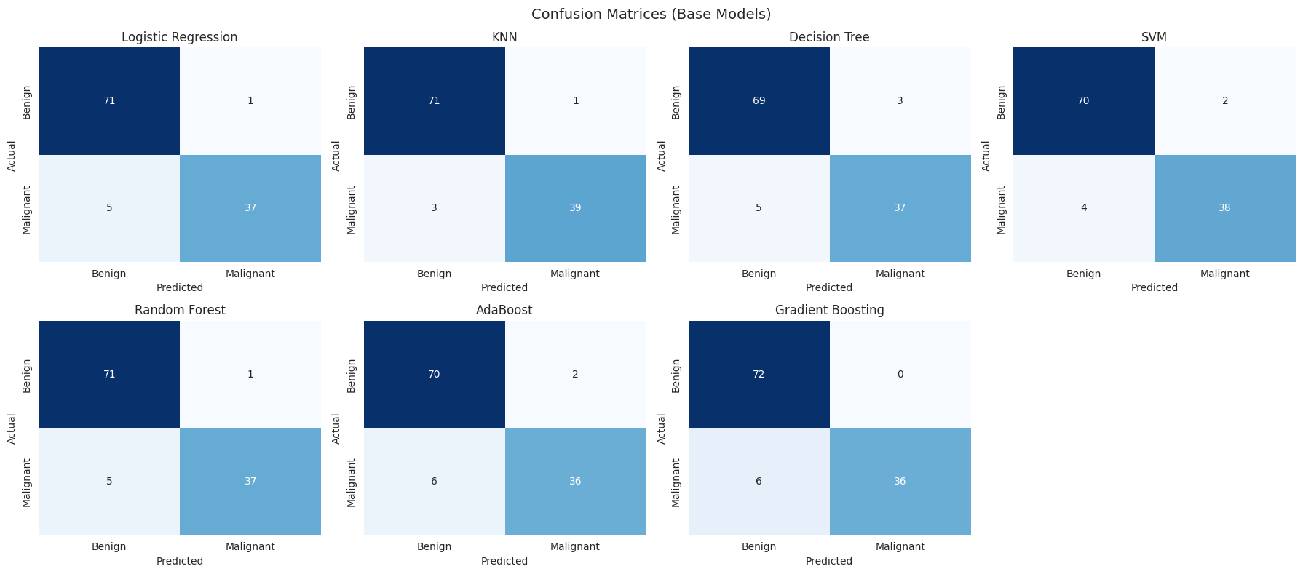
Figure 9: Confusion matrices of the base models
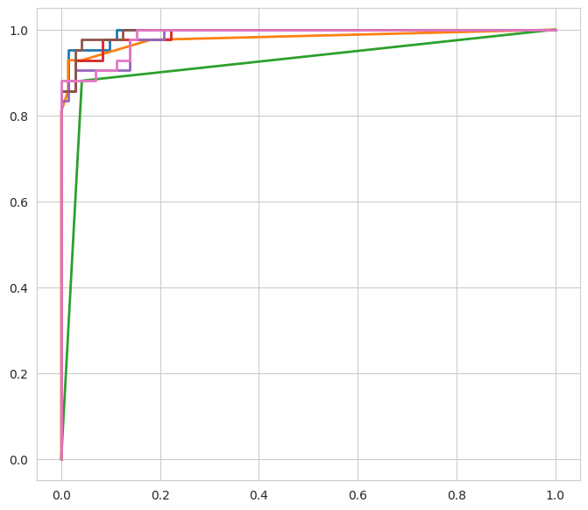
Figure 10: ROC curves of the base models
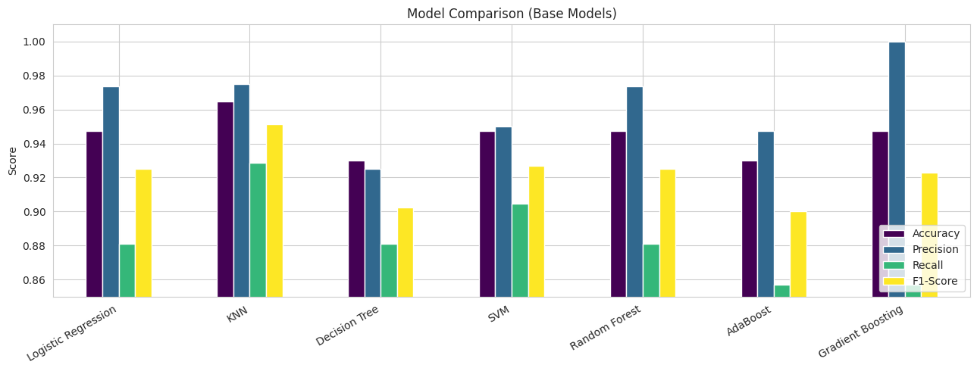
Figure 11: Comparison of base models
9.2 Cross-validation results
Stratified 5-fold cross-validation on the training data (scoring = recall) shows how stable each model is. AdaBoost has the highest mean recall (0.9235) and Logistic Regression is second (0.9059). KNN and Decision Tree have the lowest mean recall (0.8706).
Table 8: 5-fold cross-validation recall (base models)
Model | Fold 1 | Fold 2 | Fold 3 | Fold 4 | Fold 5 | Mean
Logistic Regression | 0.912 | 1.000 | 0.882 | 0.853 | 0.882 | 0.9059
KNN | 0.912 | 1.000 | 0.794 | 0.765 | 0.882 | 0.8706
Decision Tree | 0.794 | 0.971 | 0.824 | 0.853 | 0.912 | 0.8706
SVM | 0.882 | 1.000 | 0.882 | 0.824 | 0.912 | 0.9000
Random Forest | 0.882 | 1.000 | 0.794 | 0.853 | 0.882 | 0.8824
AdaBoost | 0.912 | 1.000 | 0.853 | 0.971 | 0.882 | 0.9235
Gradient Boosting | 0.853 | 1.000 | 0.765 | 0.912 | 0.912 | 0.8882

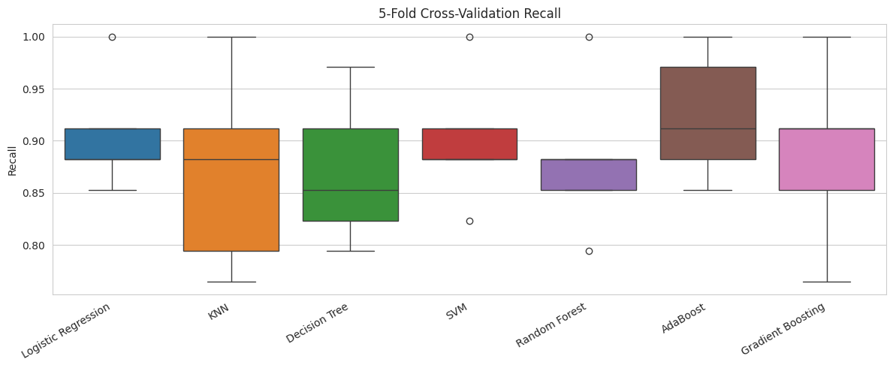
Figure 12: 5-fold cross-validation recall of the base models
9.3 Hyperparameter tuning
GridSearchCV improved the cross-validated recall of most models. Logistic Regression and SVM reached the highest cross-validated recall (0.9412).
Table 9: Best parameters found by GridSearchCV (scoring = recall)
Model | Best parameters | Best CV recall
Logistic Regression | C = 10, penalty = l2 | 0.9412
KNN | n_neighbors = 9, weights = uniform | 0.8824
Decision Tree | max_depth = None, min_samples_split = 2 | 0.9000
SVM | C = 10, kernel = linear, gamma = scale | 0.9412
Random Forest | n_estimators = 300, max_depth = None, min_samples_split = 2 | 0.9000
AdaBoost | learning_rate = 1.0, n_estimators = 200 | 0.9176
Gradient Boosting | learning_rate = 0.05, max_depth = 3, n_estimators = 200 | 0.9176

9.4 Tuned model performance
After tuning, Logistic Regression and SVM give the best test results with identical accuracy (96.49%), precision (97.50%), recall (92.86%) and F1-score (95.12%). SVM has a marginally higher AUC (0.9950 against 0.9947). The notebook selects Logistic Regression as the best model because of the ranking rule (highest recall, ties broken by F1-score); it is also the simpler and faster model.
Table 10: Performance of tuned models on the test set (114 samples)
Model | Accuracy | Precision | Recall | F1-Score | AUC
Logistic Regression | 0.9649 | 0.9750 | 0.9286 | 0.9512 | 0.9947
KNN | 0.9298 | 0.9474 | 0.8571 | 0.9000 | 0.9889
Decision Tree | 0.9298 | 0.9250 | 0.8810 | 0.9024 | 0.9196
SVM | 0.9649 | 0.9750 | 0.9286 | 0.9512 | 0.9950
Random Forest | 0.9474 | 0.9737 | 0.8810 | 0.9250 | 0.9848
AdaBoost | 0.9386 | 0.9487 | 0.8810 | 0.9136 | 0.9924
Gradient Boosting | 0.9474 | 0.9737 | 0.8810 | 0.9250 | 0.9838

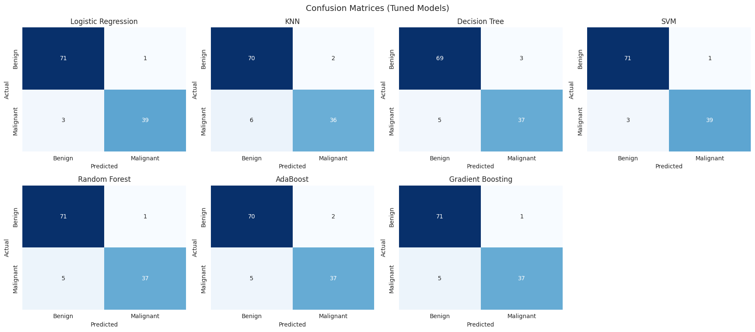
Figure 13: Confusion matrices of the tuned models
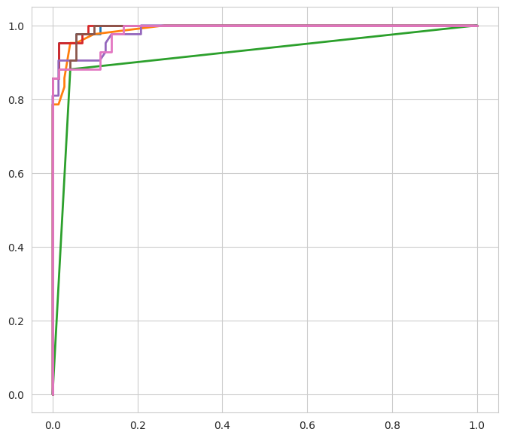
Figure 14: ROC curves of the tuned models
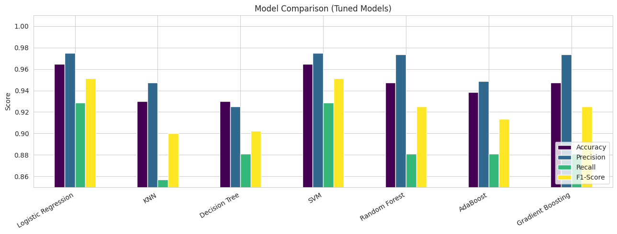
Figure 15: Comparison of tuned models
9.5 Base vs tuned comparison
Tuning improved Logistic Regression and SVM (accuracy from 94.74% to 96.49%), gave small gains for AdaBoost, and left Random Forest, Gradient Boosting and Decision Tree almost unchanged. KNN became worse on the test set (accuracy from 96.49% to 92.98%) because tuning optimised cross-validated recall on the training data, which does not always translate to the particular test split.
Table 11: Accuracy and F1-score: base vs tuned
Model | Base Accuracy | Tuned Accuracy | Base F1 | Tuned F1
Logistic Regression | 0.9474 | 0.9649 | 0.9250 | 0.9512
SVM | 0.9474 | 0.9649 | 0.9268 | 0.9512
Random Forest | 0.9474 | 0.9474 | 0.9250 | 0.9250
Gradient Boosting | 0.9474 | 0.9474 | 0.9231 | 0.9250
AdaBoost | 0.9298 | 0.9386 | 0.9000 | 0.9136
Decision Tree | 0.9298 | 0.9298 | 0.9024 | 0.9024
KNN | 0.9649 | 0.9298 | 0.9512 | 0.9000

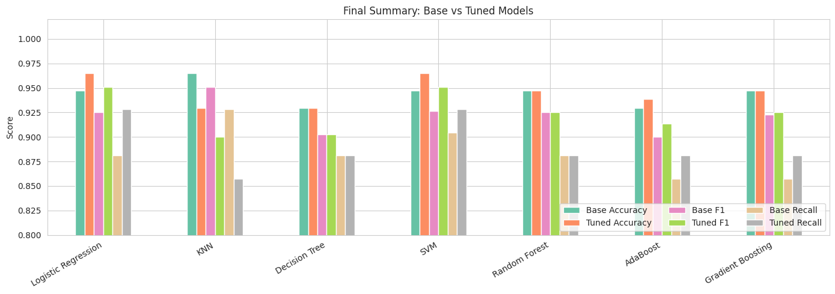
Figure 16: Final summary of base and tuned models (accuracy, F1-score and recall)
9.6 Feature importance
The tuned Random Forest and Gradient Boosting models show which of the 8 selected features matter most. For both models, radius_mean is the most important feature, followed by concavity-related features, so the size and the irregular shape of the nucleus are the strongest signs of malignancy.
Table 12: Feature importance (tuned Random Forest)
Rank | Feature | Importance
1 | radius_mean | 0.2712
2 | concavity_mean | 0.2306
3 | concavity_worst | 0.1376
4 | radius_se | 0.1090
5 | compactness_mean | 0.0881
6 | compactness_worst | 0.0663
7 | symmetry_worst | 0.0499
8 | smoothness_worst | 0.0472

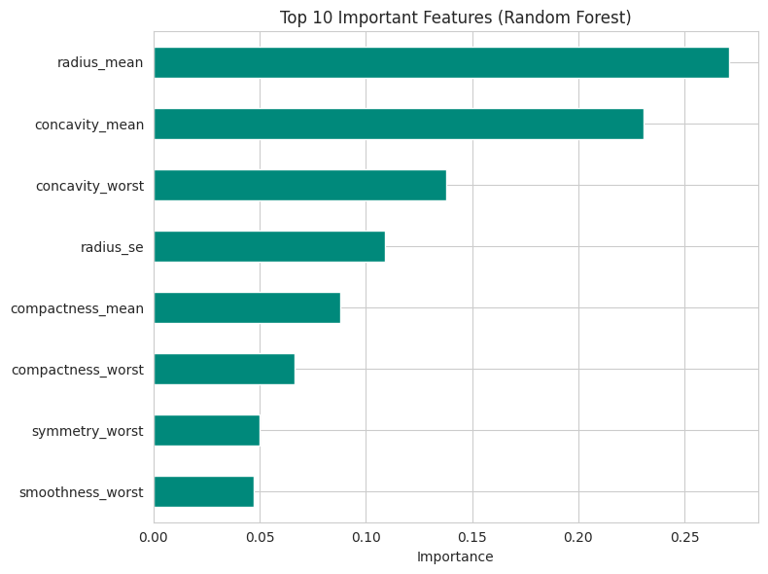
Figure 17: Feature importance from Random Forest
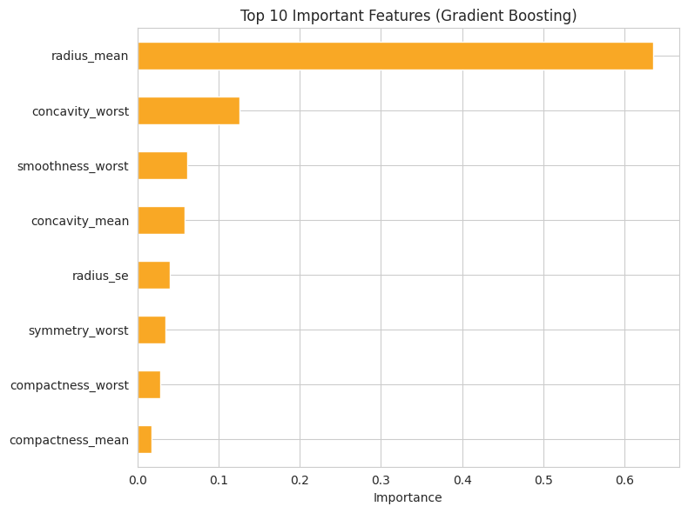
Figure 18: Feature importance from Gradient Boosting
9.7 Best model and sample prediction
Table 13: Final model: Logistic Regression (tuned, C = 10)
Measure | Value
Accuracy | 96.49%
Precision | 97.50%
Recall | 92.86%
F1-score | 95.12%
AUC | 0.9947
True Negatives / False Positives | 71 / 1
False Negatives / True Positives | 3 / 39

Of the 42 malignant cases in the test set, the model correctly detected 39 and missed 3. It raised 1 false alarm among the 72 benign cases. For a sample patient taken from the test data, the saved model predicted Benign with a malignant probability of 2.63%, which matches the actual diagnosis (Benign).
- Conclusion
In this mini project, seven supervised machine learning algorithms were applied to the Wisconsin Diagnostic Breast Cancer dataset (569 samples) to classify tumours as benign or malignant. The 30 original features were reduced to 8 by a correlation filter and SelectKBest, and the data was scaled, cross-validated and tuned with GridSearchCV.
All models performed well, with accuracies between 92.98% and 96.49%. The best model was the tuned Logistic Regression, with 96.49% accuracy, 97.50% precision, 92.86% recall, 95.12% F1-score and an AUC of 0.9947. It identified 39 of the 42 malignant cases and gave only one false alarm. SVM matched these scores, which shows that a simple, fast model can be as good as the more complex ensemble models on this data.
Recall was used as the key metric because missing a cancer case is more dangerous than a false alarm. Radius_mean and the concavity features were the most important predictors, which agrees with the observation that larger and more irregularly shaped cell nuclei are more likely to be malignant.

